My Boy Builds Coffins

My boy builds coffins with hammers and nails
He doesn't build ships, he has no use for sails
He doesn't make tables, dressers or chairs
He can't carve a whistle cause he just doesn't care
My boy builds coffins for the rich and the poor
Kings and queens; they've all knocked on his door
Beggars and liars, gypsies and thieves
They all come to him 'cause he's so eager to please
My boy builds coffins he makes them all day
But it's not just for work and it isn't for play
He's made one for himself
One for me too
One of these days he'll make one for you
For you, for you, for you
My boy builds coffins for better or worse
Some say its a blessing, some say its a curse
He fits them together in sunshine or rain
Each one is unique, no two are the same
My boy builds coffins and I think it's a shame
That when each one's been made, he can't see it again
He crafts everyone with love and with care
Then it's thrown in the ground, it just isn't fair
My boy builds coffins he makes them all day
But it's not just for work and it isn't for play
He's made one for himself
One for me too
One of these days he'll make one for you
Florence and the Machine

Refleksija:
dijakom je pesem zelo blizu, saj večinoma poznajo skupino in tudi besedilo. Zelo jim je všeč poslušanje pesmi na Yutubu. Skupaj poiščemo vzporednice med pesmijo in kratko zgodbo A.E. Poe-a. Na to pesem dijaki narišejo story board- video, kjer morajo biti vidni poglavitni elementi Maske rdeče smrti. Dijaki so to zelo spretno opravili in predstavili vsak svojo ali skupinsko uprizoritev besedila.

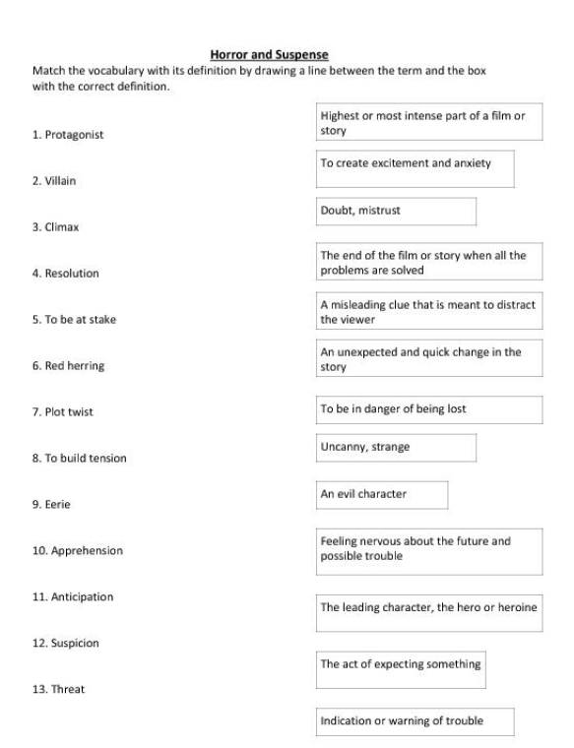

Refleksija:
Vaja je zelo koristna za razširitev besedišča in seznanitev z značilnostmi gotskega romana in grozljivke. Nove besede dijaki uporabijo pri razlaganju posameznih delov kratke zgodbe.



